Name: ___________________


nzymes Review Worksheet

- Fill in the gaps in the following sentences using the words in the box below.

different catalysts function the same amino acids

i) Enzymes are biological ………………… that speed up chemical reactions in
living organisms.
ii) Enzymes are protein molecules, which are made up of long chains of ………...……….
iii) The sequence and type of amino acids are ………………… in each protein, so they produce enzymes with many different shapes and functions.
iv) The shape of an enzyme is very important to it’s ………………….


- Label the image below with the following terms: active site, substrate, enzyme.
+
……………….....
………..….......
………..….......

- Explain what would happen if a substrate molecule with a different shape to the enzyme came into contact with the enzyme’s active site.
………………………………………………………………………………………………………
- There are many factors that affect the rate of enzyme-catalyzed reactions, including temperature. Name one other factor.

………………………………………………………………………………………………………
- What would happen to an enzyme if the temperature and pH changed significantly beyond the enzyme’s optimum level?

……………………………………………………………………………………..…………...
- How would this affect enzyme activity? (increase, decrease, or stay the same?)

……………………………………………………………..…………………..…….…………

…………………………………………………………………………………………………………
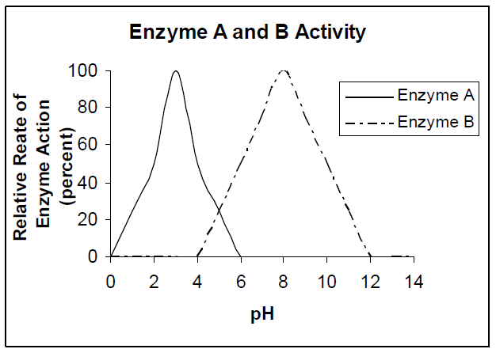
- Look at the graph to the right.
  - At what pH is Enzyme A working at its optimum rate? …………………………..
  - Since Enzyme A is found in the stomach, what is the probable pH of the stomach? ……………
  - If Enzyme A were produced in the intestine, would this enzyme still carry out its usual function of digestions? Explain. ……………………………………………………….
……………………………………………………….
……………………………………………………….
Use the following information to answer the questions below:
1. Match each word with the correct letter on the picture.
Active Site
Substrate
Enzyme
Glucose
Fructose
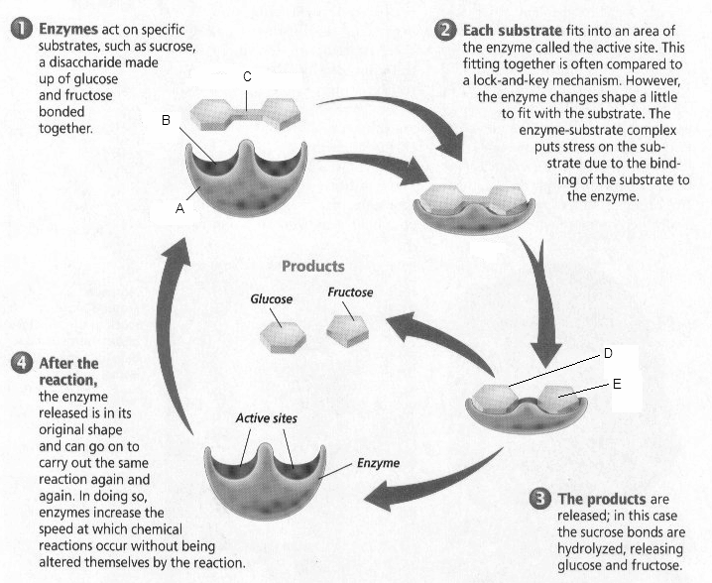
Sucrose is a sweetener found in many candies. It is a carbohydrate disaccharide made up of glucose and another sugar called fructose. When we eat sucrose, it must be digested or broken down into smaller substances, which our cells can absorb. An enzyme (protein) called sucrase speeds up this chemical reaction by breaking the chemical bond in sucrose, the substrate. High heat and strong acids or bases destroy the enzyme and would stop the chemical reaction. The only way to make the reaction go faster is to add more enzymes. Scientists support the “lock and key” model below for how an enzyme speeds up chemical reactions. The letters “ase” at the end of words help us identify enzymes.
C
B
A
D
E

- What is the substrate in the picture above? …………………………………………………….

- What is the name of the enzyme? ………………………………………………………………

- What 3 letters in the enzyme’s name tells that it is an enzyme? …………………………….

- How can you tell from the diagram that sucrase is not used up during the chemical reaction?
…………………………………………………………………………………………………………………………………………………………………………………………………………………………
- What type of proteins speed up a chemical reaction? ……………………………………………..

- How are enzymes destroyed? (two ways) …………………………………………………………..

- What would you happen if the above enzyme was saturated with a different substrate?
…………………………………………………………………………………………………………………………………………………………………………………………………………………………..

